**UML Diagrams for problem statement 2 :**

USE CASE DIAGRAM

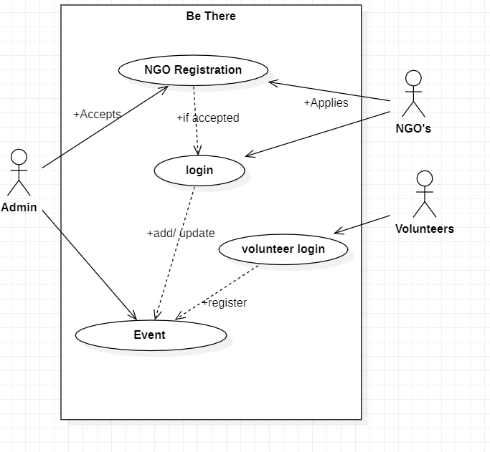

* Volunteers who want to register for any social event posted on the website by any NGO can apply and participate after logging in.
* Admin will take care of verifying the volunteers and NGO’s.
* NGOs can post the events after getting accepted by the admin.

CLASS DIAGRAM

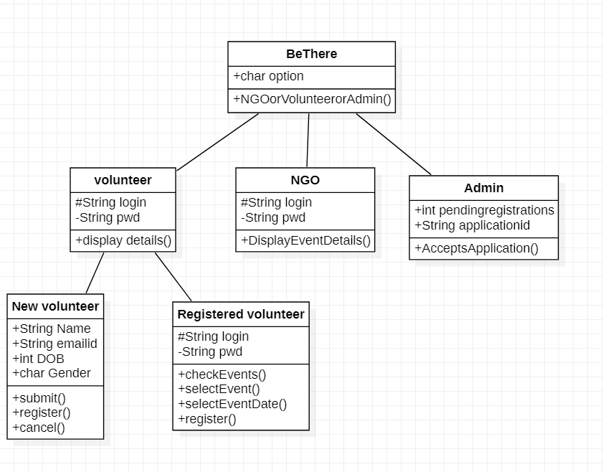

* Volunteer-The volunteer has attribute such as name and password and operations are:

Log in, select an event, register and logout. The applicant login and fill in the details that are required for registering for the event.

* THE DATABASE-The database has attributed such as name and operation is store. The purpose is to store the data.
* ADMINISTRATOR- The administrator has attribute such as name and operation are get details, verify details and send to NGO. The regional administrator gets the details from the database and verifies them with their database.
* NGO-The NGO has attributes such as name and operation that are updating event details. The NGO
* Get the details of volunteers registered from the database.

SEQUENCE DIAGRAM

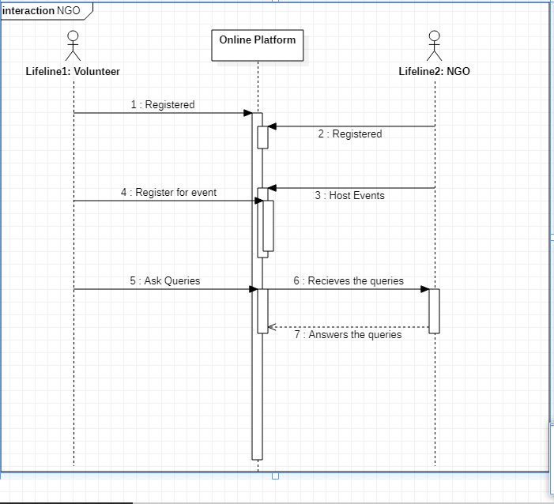

* Volunteer or NGOs can register at any time, the admin has the access whether to deny or accept the request of them.
* They can post their quires, Admin will answer them as a reply.

COLLABORATION DIAGRAM

* An NGO can register/login to the website and conduct social events in which people on the website can volunteer for.
* A volunteer can log in and check for the available events to participate in and register for any event.

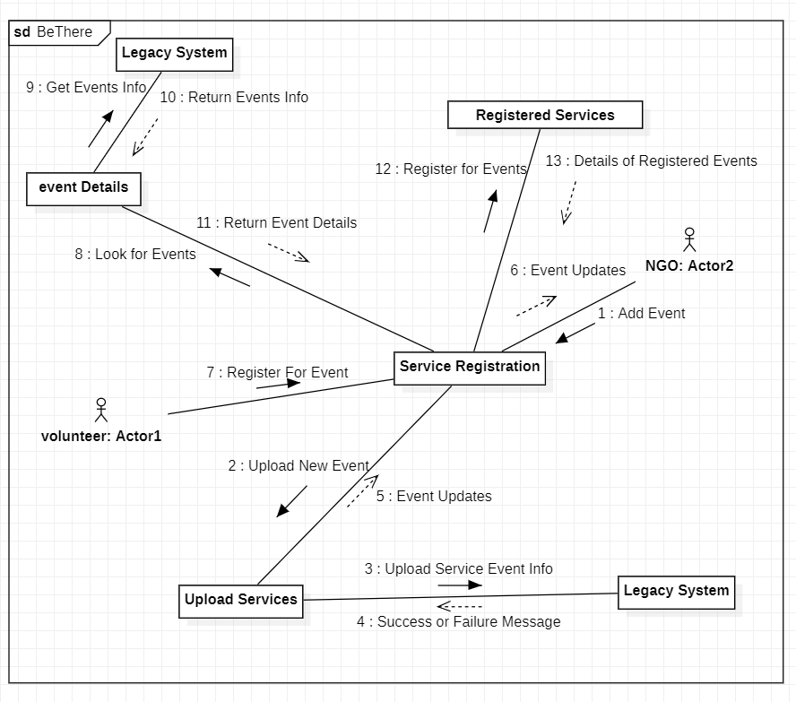

STATE CHART DIAGRAM

* The states of the BeThere application are denoted in the statechart diagram.
* Login State represents authentication for logging into the site and checks if the user is an authorized NGO or an authorized volunteer.
* When the NGO logs in, the ‘add event details’ state allows them to add/update/delete their events and can view the registered volunteers for its events and either approves or denies their application and it is covered in the ‘Approve or Deny’ state.
* When a volunteer logs in, the’ View events’ state displays all the events, and filter events state filters down the events according to the user requirements. Then he/she registers for his/her interesting event.
* The last state i.e., Confirmation gives the status of the volunteer’s application.

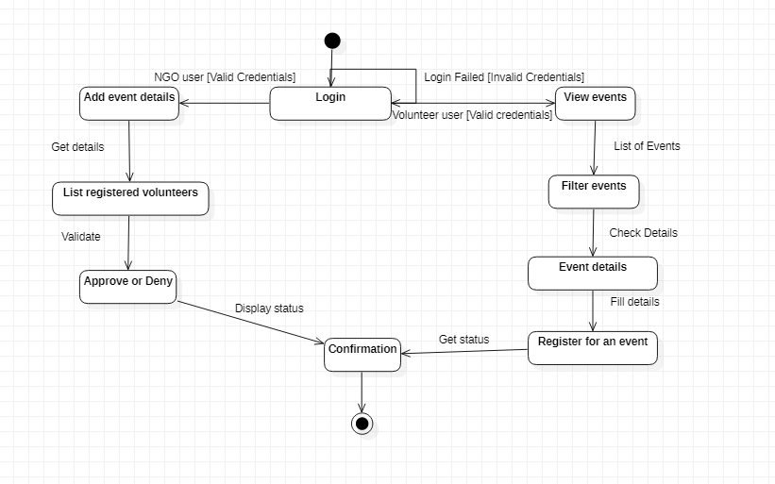

ACTIVITY DIAGRAM

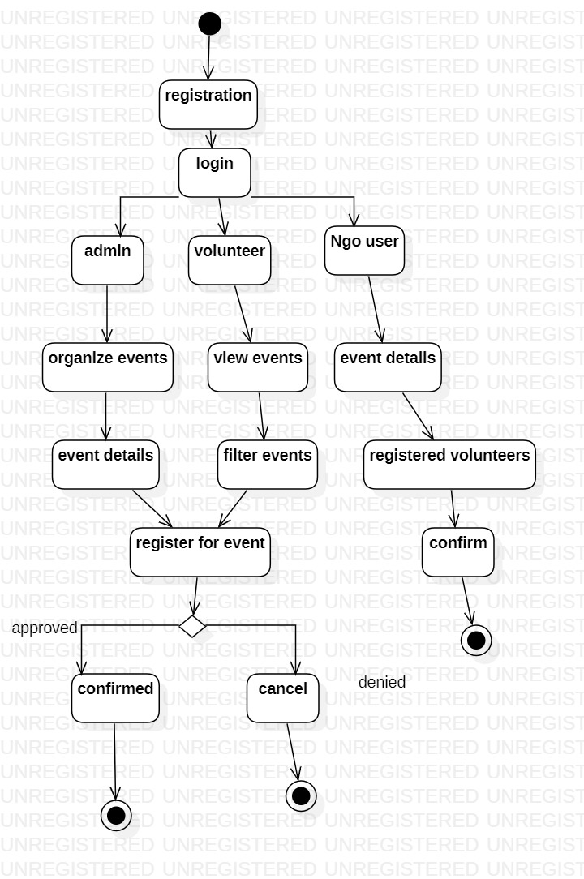

* The states of the application are denoted in the activity diagram.
* login action represents authentication for logging into the site
* When admin logs in they organize the events and also list out event details
* When volunteer logs in they view the events and filter out the events
* The admin and volunteer action leads to the registration of an event
* When registration of an event successful we get the confirmation or else the event is canceled
* When NGO logs in add/update/delete their events and can view the registered volunteers for its events and either.

COMPONENT DIAGRAM

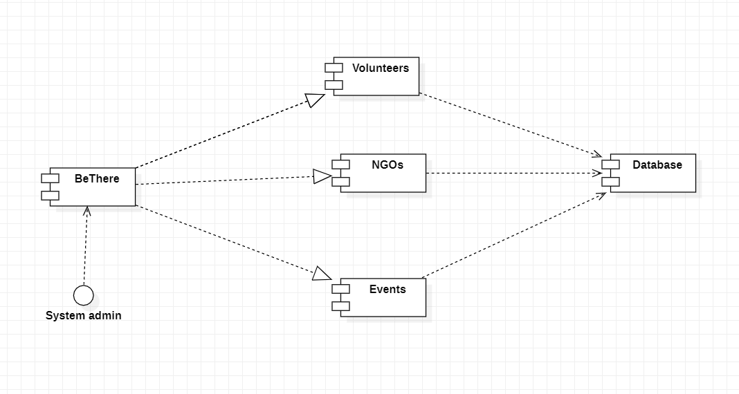

* This application mainly has 3 components: volunteers on the website, NGOs on the website, and events details that are being conducted by NGOs.

* All the components are can get information from the database, ie they are connected to the database.